SUBQUERIES:

Subquery 1:
Find films with rental rates greater than the average rental rate.

SELECT * FROM film where rental_rate > (SELECT AVG(rental_rate) FROM film);



Subquery 2:
Display customers who made payments higher than the average payment amount.

SELECT * FROM customer WHERE customer_id in (SELECT customer_id FROM payment WHERE amount > (SELECT AVG(amount) FROM payment));

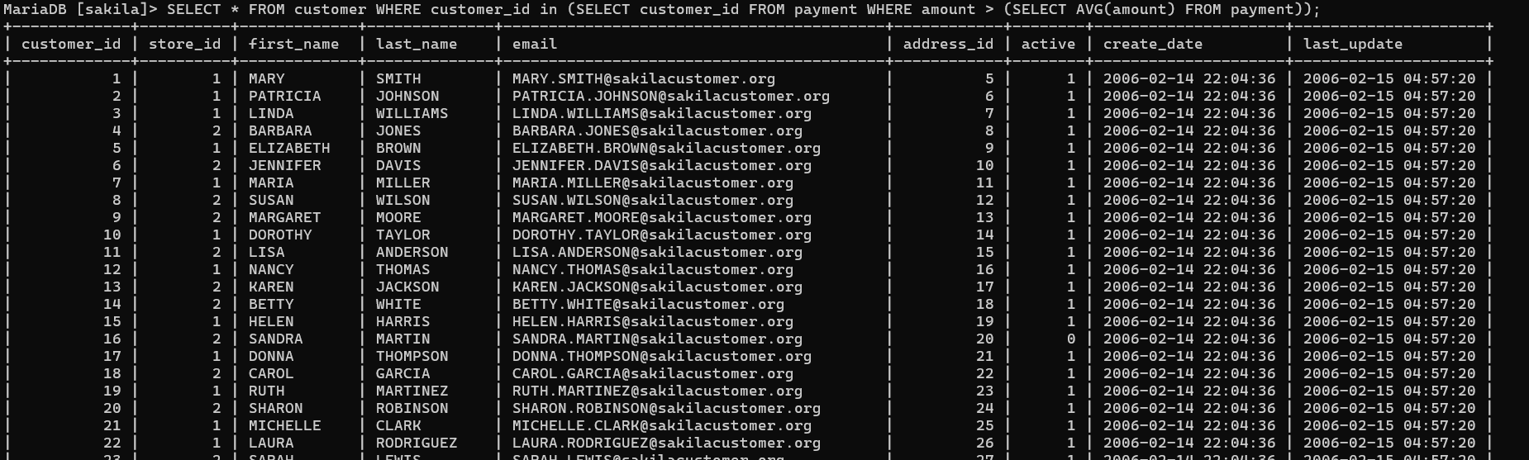

Subquery 3:
Find the film with the longest duration. Hint: use MAX()

SELECT title, length FROM film WHERE length = (SELECT MAX(length) FROM film);
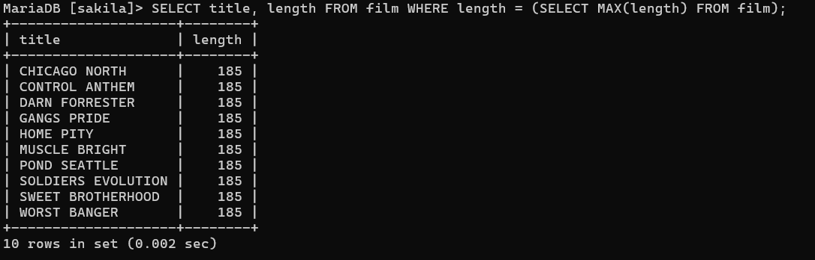

Subquery 4:
Display films that belong to the same category as “Comedy”. Multiple subqueries. Tables to use: film, film_category, category

SELECT title FROM film WHERE film_id IN (SELECT film_id FROM film_category WHERE category_id = (SELECT category_id FROM category WHERE name = "Comedy"));

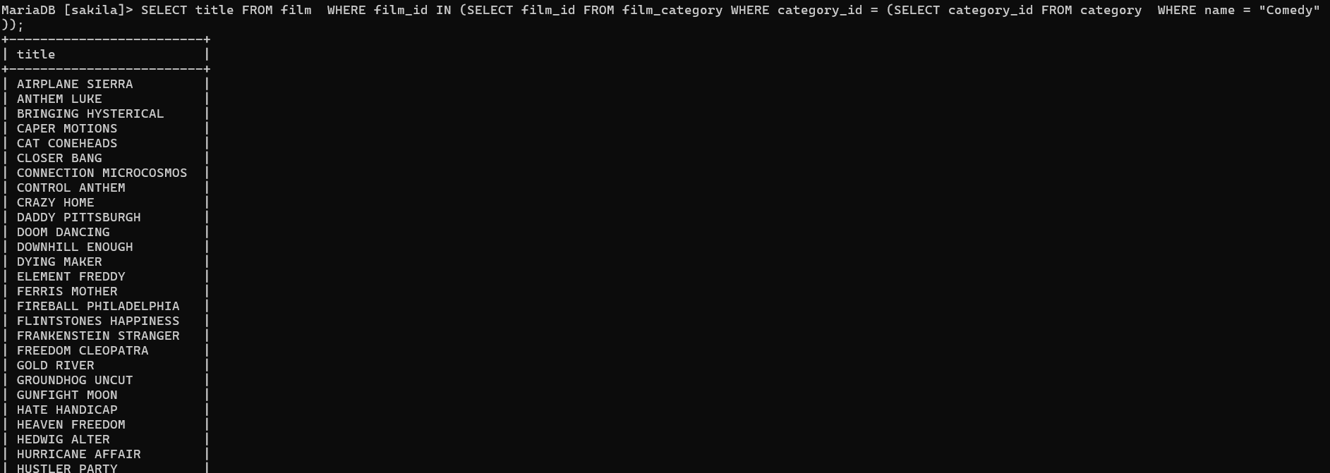

INNER JOIN:

Inner Join 1:
Display the customer’s first name, last name, and their address. Tables to use: customer, address

SELECT c.first_name, c.last_name, a.address FROM customer c INNER JOIN address a ON a.address_id = c.address_id;

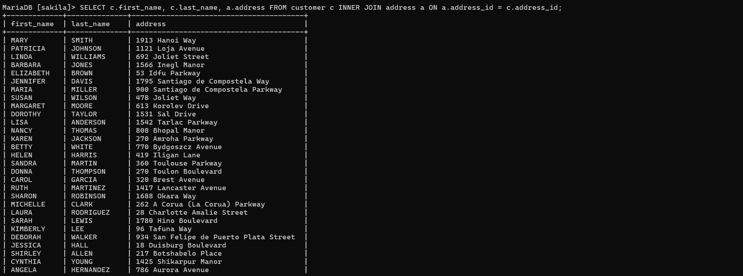

Inner Join 2:
Display all films together with their language name. Tables to use: film, language

SELECT f.title, l.name FROM film f INNER JOIN language l ON f.language_id = l.language_id;



Inner Join 3:
Show the staff members and the store they manage. Tables to use: staff, store

SELECT s.first_name, s.last_name, st.store_id FROM staff s INNER JOIN store st ON s.staff_id = st.manager_staff_id;
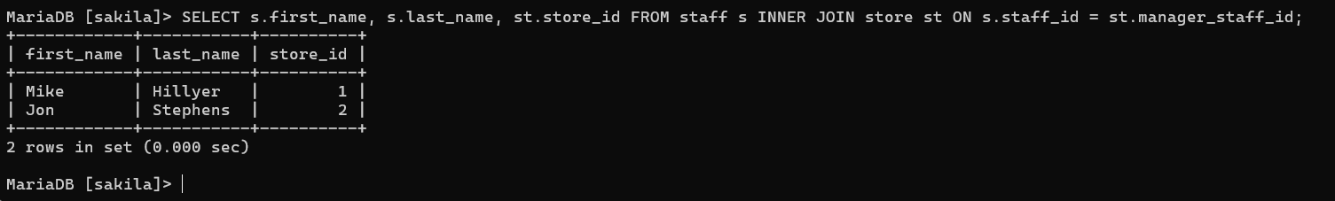

LEFT JOIN:
Display all films and their inventory IDs, including films with no inventory records. Tables to use: film, inventory

SELECT f.film_id, f.title, i.inventory_id FROM film f LEFT JOIN inventory i ON f.film_id = i.film_id;
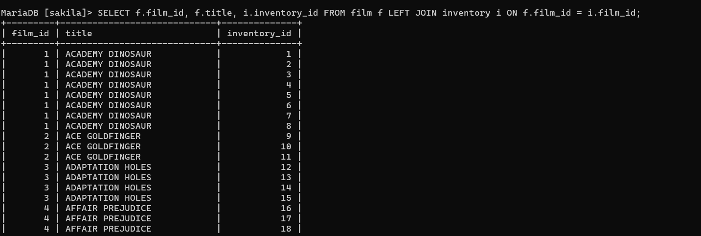


RIGHT JOIN:
Display all payments and the customer who made them, including payments without matching customer information LIMIT 50. Tables to use: customer, payment

SELECT c.first_name, c.last_name, p.payment_id, p.amount FROM customer c RIGHT JOIN payment p ON c.customer_id = p.customer_id LIMIT 50;



To Fully test i remove customer name from customer_id = 1



